IN THE PHASE ONE SURVEY WITH OTIS
When a user first gets sent an assessment, and hits ‘start my assessment’ in the email, this is what they see…they are already halfway through the assessment
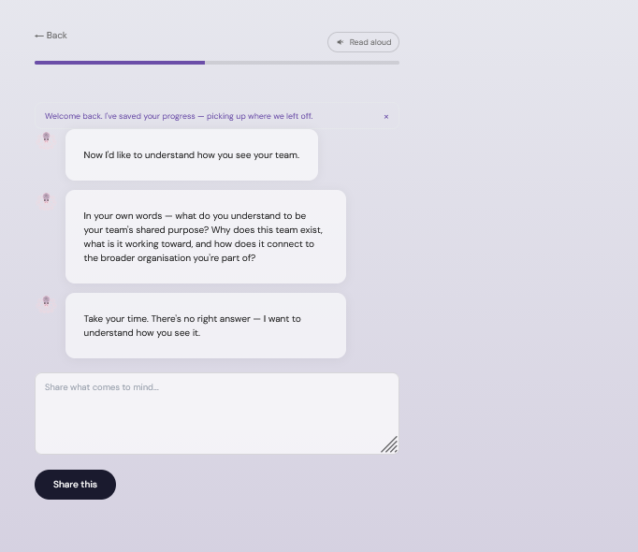

IN the file LandingStep.tsx, we should keep that text. And after it says “Here's what I think I know already.” Then we move from the ‘introduction’ section to the ‘personal &team info” which starts with showing:
- Your name is [ ] and you’re located in [ ], your team role is [__], is that right? (yes, that’s me /no, that’s not me button)
- If yes. “It’s nice to meet you [ ].” (this is on the same page as the text above)
- If no. “Sorry about that. What did I get wrong?” (comment box appears) after they enter the comment. “it’s nice to meet you []” (this is on the same page as the text above)
This is what it looks like right now, so we want to change that to fit the format above: 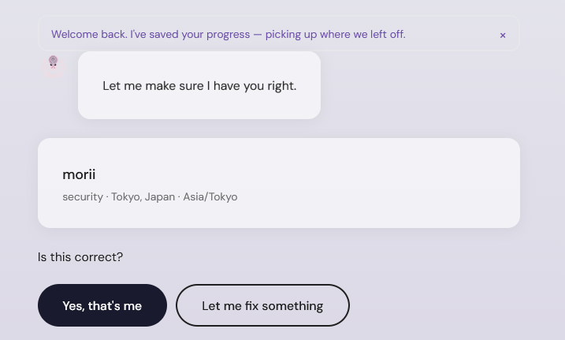

When the team roster shows up and asks if anyone is missing, if you press yes and add a name and submit, your addition never shows up anywhere. You can’t see it or edit it again.
also, when it asks you about how long you’ve been on the team, and you skip, then that disappears and there’s no way to go back and add it in later or see it again if oyu wanted to.
(start section) “I’d like to know more about you. It’s completely optional to share.
Mind telling me…”
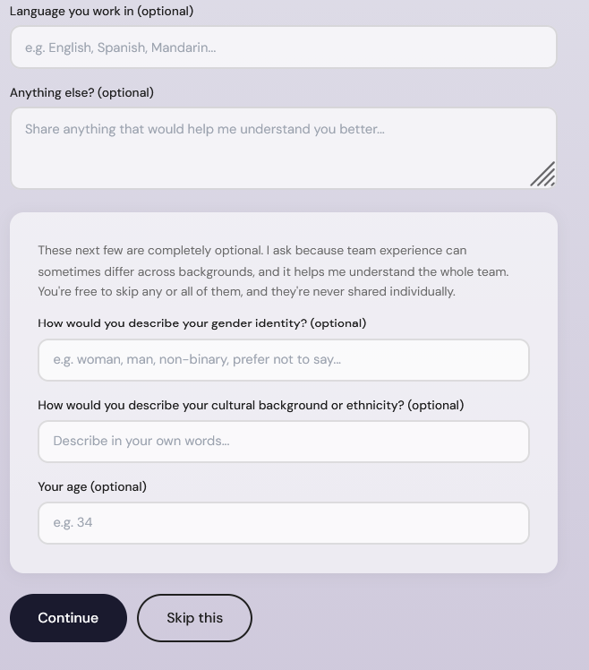
right now it looks like this but I wanna change it:
“what languages you speak”
“your gender identity”
“your age”
“your ethnicity, nationality, or cultural background”
“Anything else you’d like me to know” (text box inside saying: loved ones, passions, talents, favorite things, etc. )
(start section) Then we have the team roster here instead. “I also have some information about your team. By the way, I see a team as a group of people with complementary skills, who depend on one another to reach common goals. You might be a part of several teams, and here are the members of one of them (end section)” then below this text it shows:
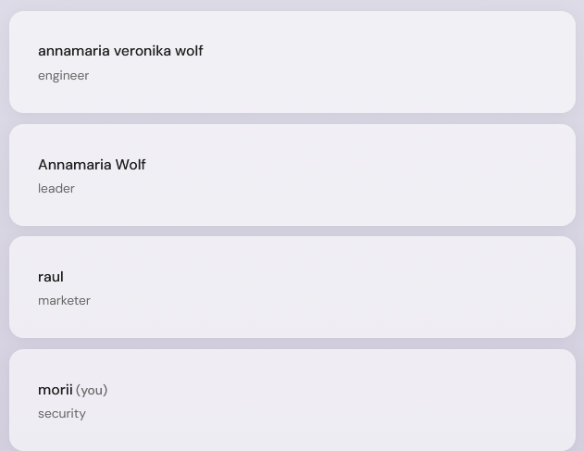
(the roster stays visable as the next bubbles pop up. I want to remove the role details from the names. Just have the names)
(start) “Can you tell me in your own words what this team exists to do. What do you work together for, what’s our shared goals and purpose? How does this connect to your organization more broadly?” (end) (text box)
- Here we should prompt, but only if members give very non-discript answers, if they answer the question only partially, say they ‘don’t know (CLAUDE: consider how we have helped to prompt members in the past and prepared for different responses, to set up some guardrails. We should only prompt if needed”.
(start) “thanks for telling me. By the way, do you feel anyone is missing? Someone core to the team but not mentioned? When answering, remember that you may work closely with some people who are members of other teams, not this one. (here we have those buttons and the option to add)”
(start) “And how about your role on the team? What skills, knowledge, or abilities do you contribute?” (end) (text box)
CLAUDE: similar to above, only prompt if needed. (end)
(start) “And when it comes to your team members, how frequently do you work with each of them?” (end) (text box)
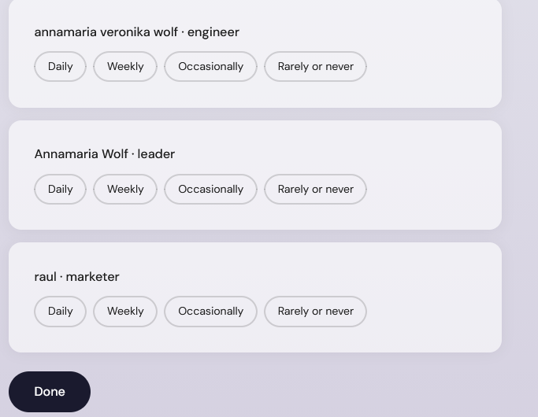

(Start) “Thanks [Name]. I’d like to tell you more about why I’m here. I help assess and build team **psychological safety: the shared sense that it's safe to be oneself, speak up, and take calculated risks without fearing backlash**.
Today, I’d like for us to assess what psychological safety currently looks like on your team. And later, once everyone on your team has responded, I’d like to help you build it up. (End)”

“(Start) Before that, please know that everything you tell me can be held private if that’s what you want. If you want to be anonymous, I won’t share your exact words with anyone. Instead, I’ll paraphrase and describe patterns that I see across responses from your whole team, and replace your name with a random ID.
Please note that complete anonymity can never be guaranteed, especially with small groups.”
What would you like to do (you can change this decision later).
(here we have this before ending the block 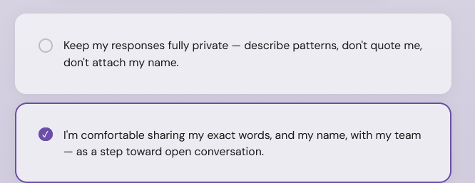 (end))
(this is what we have right now, so we want to change that: 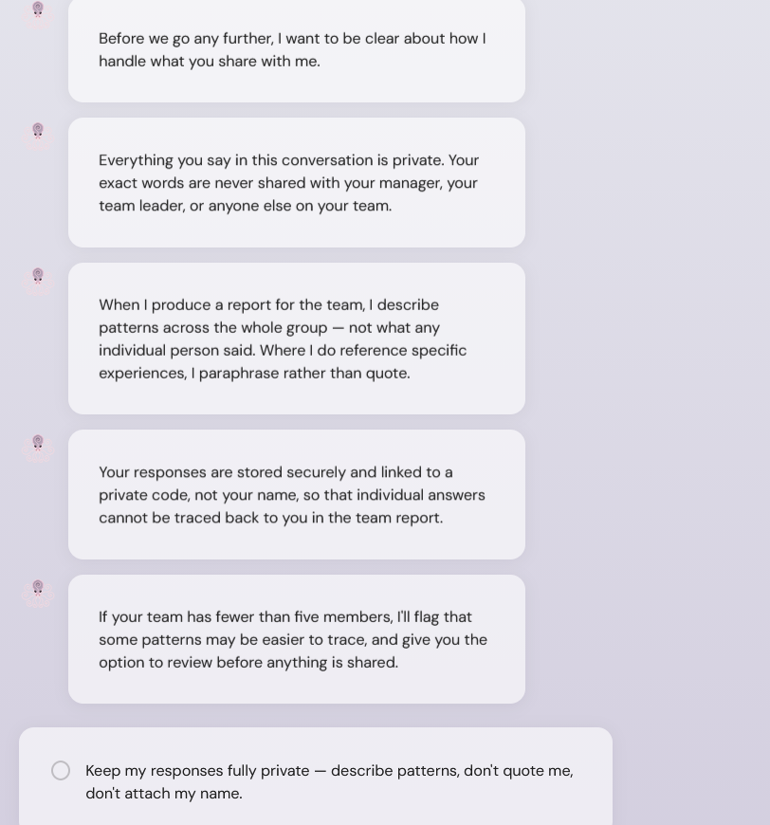)

(start) “Got it. Do you have any questions for me at this point? (show text box underneath with no extra text)
Take a look at some frequently asked questions, if you like. “ (show ‘FAQ’ WITH A drop down, and then show these 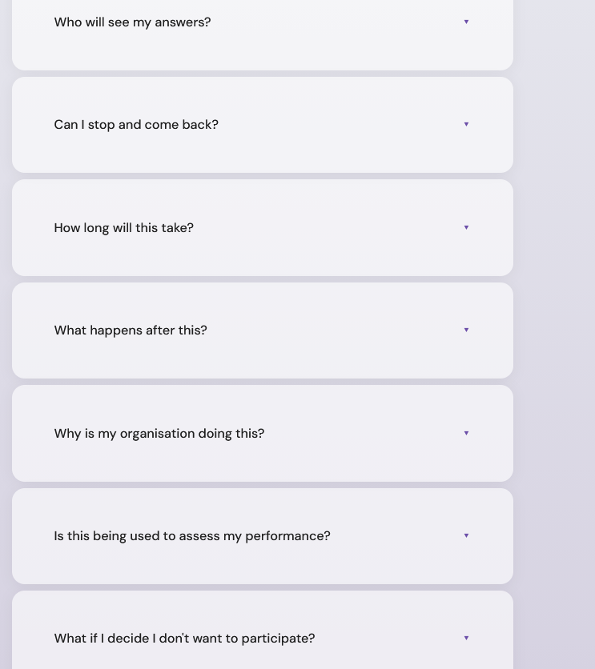) (end)” instead of (Next) button, here have (Start the Assessment). And here I want a different bar in the time-line bar because now we’ve moved from the intro, to the personal / team info gathering, to the psych safety assessment. Actually, we can have the progress bar sectioned and titled like that (Introduction (ends before the part where it says “Now

I want to remove this: 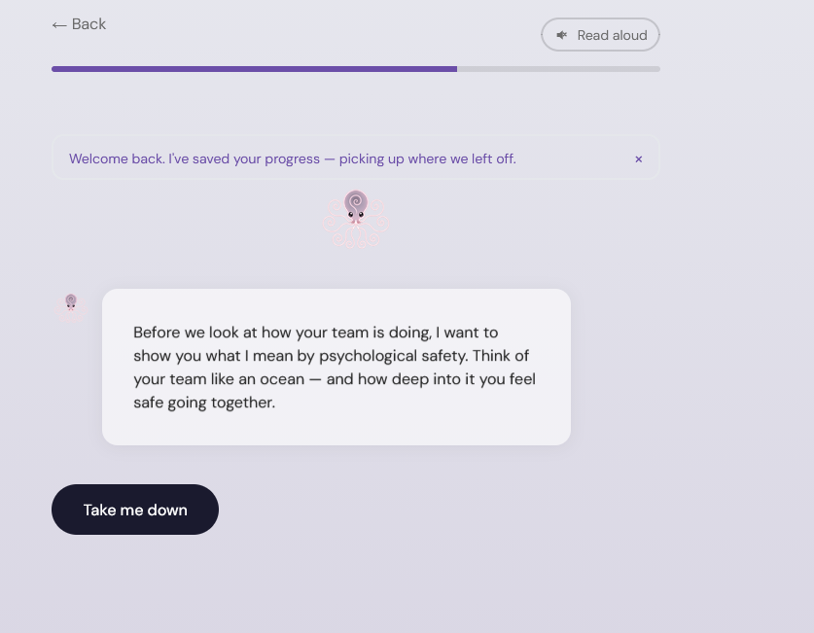
I want to keep this but change some things:
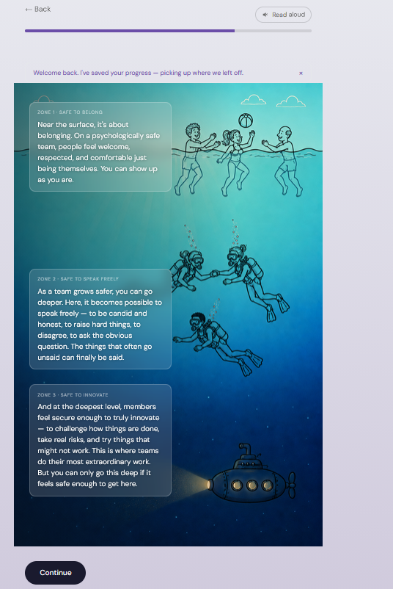

At the top, above the image, we have in larger text “Think of how save you’d feel exploring an ocean with your team”. Notice how the text boxes are not equi-distant.Zone 2 should be moved to be in the center of the other 2 boxes
I want to remove the following: 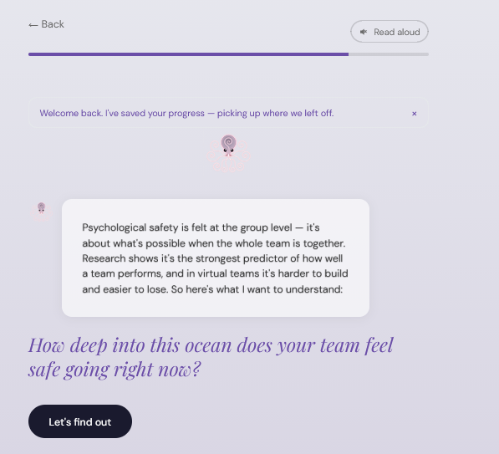
Replace it with :

start) “Think about your team as a whole, and the times when you’re all together. In meetings, project work, group messages, etc. Based on how I’ve described psychological safety, do you think it’s important for your team? Why or why not?”(end)
- Here have prompting only if they don’t get at the why//why not if answering yes/know etc.
(Start) “Thanks. Now, please read the following statements and tell me how much you agree with. “ (End) (when you press next, this sentence stays at the top of the page above the image:
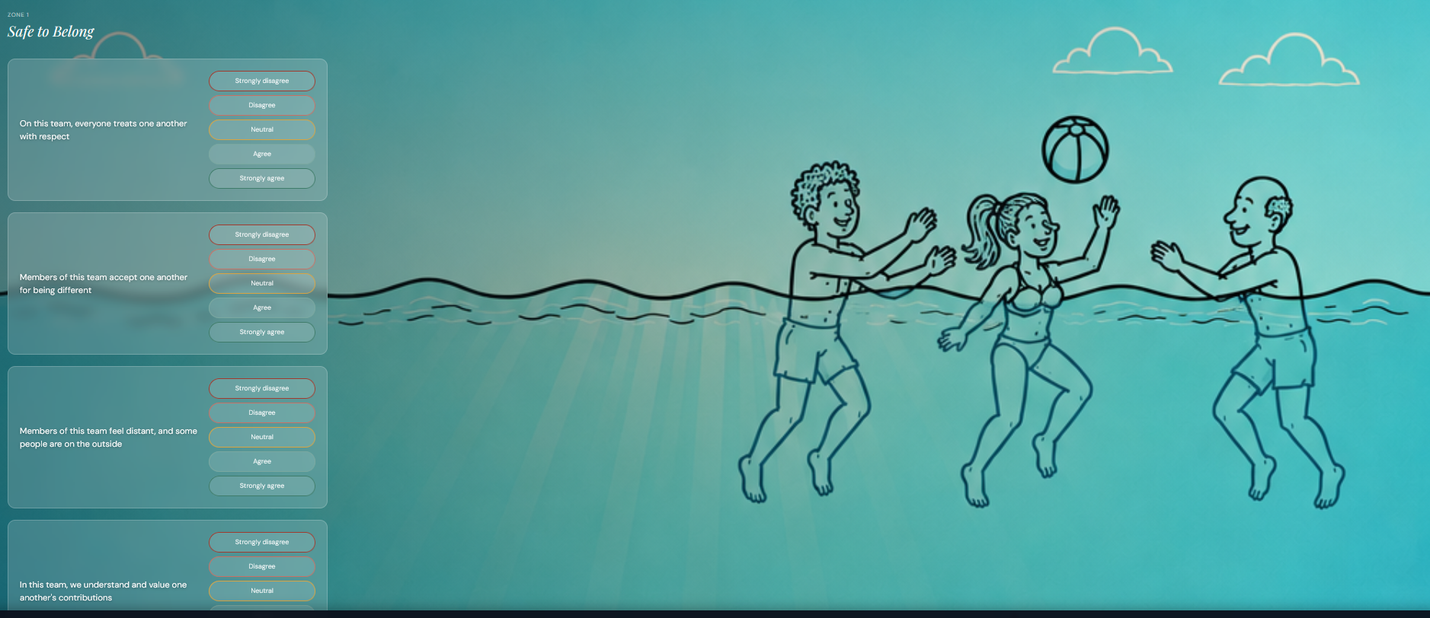
(CLAUDE: is it a bad thing that we only have 1 reverse scored item…?)
after the questionnaire, there is the finishing page:
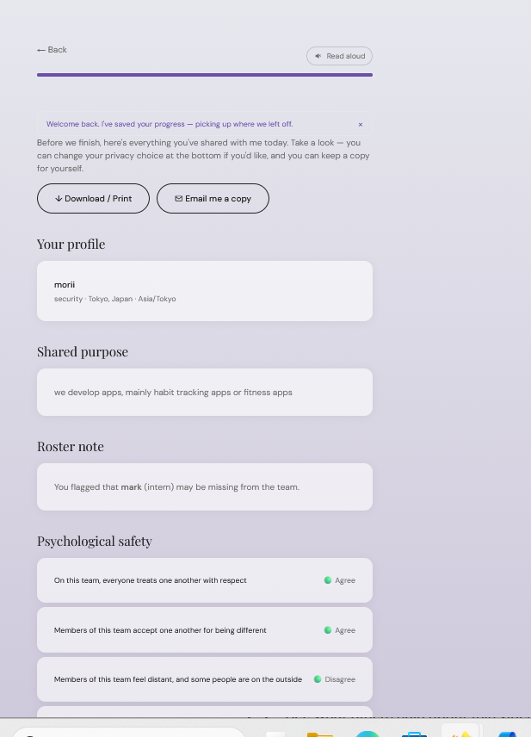
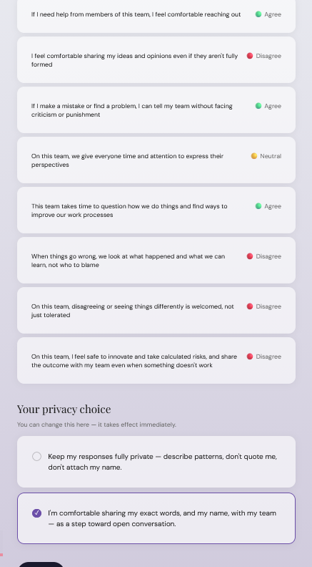
but it’s too abrupt. I think this should come later.
first:
(start) “Thanks [name], that’s all I need! Here’s what happens next.
I’m going to speak with everyone on your team and run some analyses. The next time we meet, we’ll discuss the results to pinpoint where psychological safety is lacking and how to build it up. “ (end).
“(Start) “Before we end, take a look to see if there’s anything you want to edit. You can download this information, or find it again by logging into your profile (here’s where we show the above report) (end)”
Take care, [name]”
(Submit & Finish’ button)
---
I mentiond having 3 sections
-introductions
Personal & team info
Psychological safety assessment
-Finish (small bar probably)
I’d like to have different colored bars , and possibly a slightly different background or color scheme for each. Make it subtle and classy. Not overly bold or flashy.
on my website page for Otis AI (which I gave to calaude along with the logo for OTIS mascot), I have Otis floating ever so slightly on the page. Please check the code that I shared for that web-page to try and re-create this floating effectin. I want this to be central, and for the icon to be relatively large, for all of the introduction bubbles.
Unlike the current setup, the bubbles or chat bubbles should be navigated through with an arrow click. In the LandingStep the text in the bubbles is what should appear on the page, before ‘next’ button. And here in the document, the (start) (end) represents what’s on the page before ‘next’ is clicked.
If it’s possible, I want there to be a ‘read aloud’ toggle on the screen, where when pressed, audio is automatically read aloud every time the text appears on the screen after pressing ‘next’. Don’t do this for survey items, roster names, text in buttons.
also, in text boxes, if we have that feature built in then have a little microphone or something so people can use voice to text if they want.

